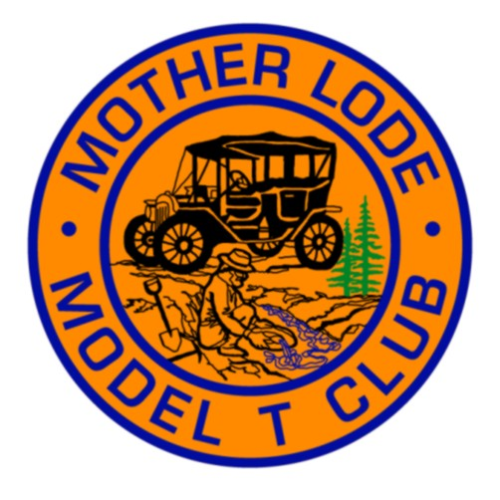

**Monthly Newsletter of the**

**Mother Lode Model T Club**

**http**[**://www.motherlodemodelt.com**](http://www.motherlodemodelt.com)



**September 2014**



**Activities at a Glance**

**♦ September 11 - Thursday, Monthly Meeting.**

**Sizzler at 13570 Lincoln Way,  Auburn.**

**Come for dinner at 5:30 - 6 pm.   
    Meeting will start at 7 pm.**

**♦   September 16, Tuesday, LOL Lunch,**

**11:30 Am, Happy Wok Chinese Restaurant,**

**Auburn. (Located in the     Elm St.**

**Shopping Center)  
     Hostess: Junette Avey-Brown  916 436-4176**

**♦**  **September 14** - **Antique Autos in History Park**

in San Jose, Sponsored by SCVMTC. **Some of us are**

**planning on going.**

**♦ September 20 - Tour to mining museum**

**near Chicago Park- Vern & Kenny Marriott**

**♦ October 25 - Annual Fall Colors Tour -**

**Lindstedt's**

**♦ Dec 7 - Christmas Party, Auburn Valley**

**Country Club - Eula Marriott**



**August Breakfast Tour**

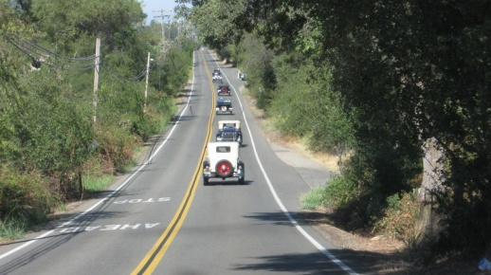 **We assembled at Raley's on a mild August morning. Russ and Nita greeted us with some snacks to hold us off until breakfast. Russ explained the driving route and we were off to a leisurely drive through the countryside.**

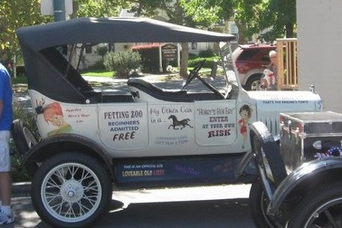 **When we arrived in Lincoln, Junette and Nathan were there waiting for us in the "Skidoo T". It was good to see that car out again. We headed into Kim's Country Kitchen for great hospitality and some good food.**

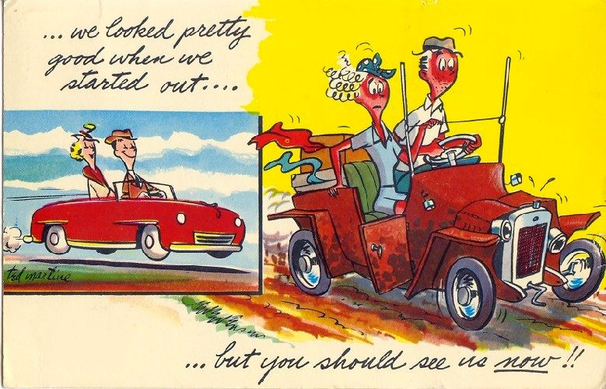**After breakfast we headed out the back door and into the Lincoln Area Archives Museum. Our docents were friendly and willing to answer all our questions. The museum has an impressive display of artifacts and photographs of the life styles of the early settlers to the Lincoln area. After the museum we all headed home. Most of us were back home by noon or so. Thanks Russ and Nita for a great tour and this good idea for a *Beat the Heat* tour.**

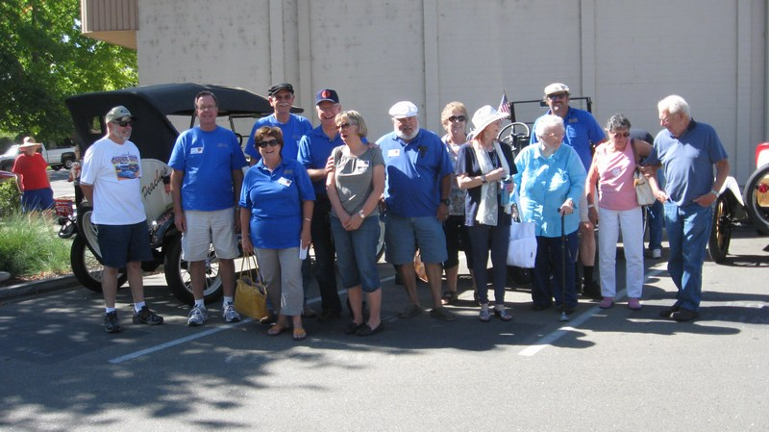

**pg 1**

**September Tour Info**

**September 20, Leave Raley's at 9 am. Vern and Kenny Marriott have set up a tour of a private mining collection in the Chicago Park area. This is a private collection and one of the best.**

**Then we will tour a few miles to Grass Valley for lunch at a local Chinese Restaurant. Sign up at the meeting or call Vern.**



**LOL - Lunch**

**September 20 - WEDNESDAY, 11:30 AM - All ladies in the club are invited to join in for Lunch at theHappy Wok Chinese Restaurant, Elm Shopping Center, Auburn.**

**Hostess: Junette Avey brown 916-436-4176**

**Welcome New Member**

|  |  |
| --- | --- |
| Doug Avery  P.O. Box 604  Cool, Ca 95614  H-530-889-0650  C-916-835-2665  dfavery@earthlink.net | Doug has purchased a 1923 TT C-cab and states it needs a few parts and some restoring before touring.. |

*Please copy into your 2014 roster.*



***Swap Meet Trailer Work Day***

*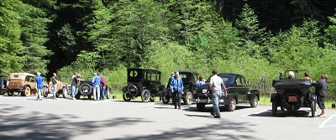The trailer has been reviewed and a list of repair items made. Before wet weather we must remove the air conditioning unit and cover and seal the hole, repair a small hole in the rear and caulk all seams and coat the roof. One shelf on the inside needs a new support and it needs two tires and wheels. We are also exploring making the sink operational with a water and drain hook up. Once these items are done we then need to sand it down and paint it. A list of materials needed will be presented at the meeting. The work dates will be finalized at the meeting. Date being considered are September 13, 27, or October 11. Check your calendars.*



**Board meeting - Monday, September 8, 6 pm, Round Table Pizza, Loomis.**

**Show Off your Club Affiliation**

**Club Logo Items**

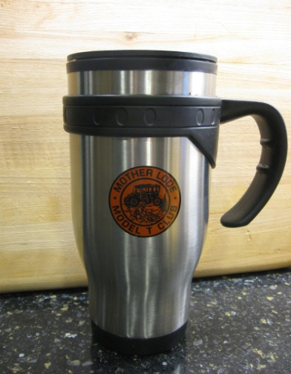Travel mugs with club logo are available to purchase for $10.00 each. These are really nice, stainless steel with lid. Call Steve Short to get yours. 916-791-7087.

*********

**Club Shirts**

We also still have a small supply of shirts with the club logo. Blue Tee Shirts with the logo on the back and club name on the front. $10. ea. Sizes M, & XL & 2XL. Polo shirts with the club name on the front above a pocket. $22. Sizes M, XL. Call John Saylor 916-723-1613 to reserve yours.

**\*\*\*\*\***

Embroidered logo patches both large and small are also available. These can be sewn onto jackets or other items of your choosing. Contact Kitty for these items.

*****

**Cub Logo Hats**

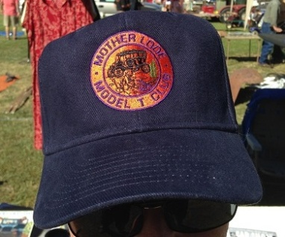Member Jerry Anders has a limited supply of dark blue hats with the gold club logo embroidered on. They are $10 each. See Jerry at a meeting. Contact him at 916-390-1392.

**Club Sweat Shirts**

Get ready for the cool season. We are looking to order some sweat shirts with the club logo on the back and name on the front similar design to the Tees. Styles of hoody, crew, zipper or not. Sign up at the meeting for your style and size. Approximate price will be 25.00 depending on style and quantity. Price breaks at multiples of 12.

***********

Redwood Tour, May 2011

*T Diggins', page 2*

**Antique Autos in History Park**

**September 14**

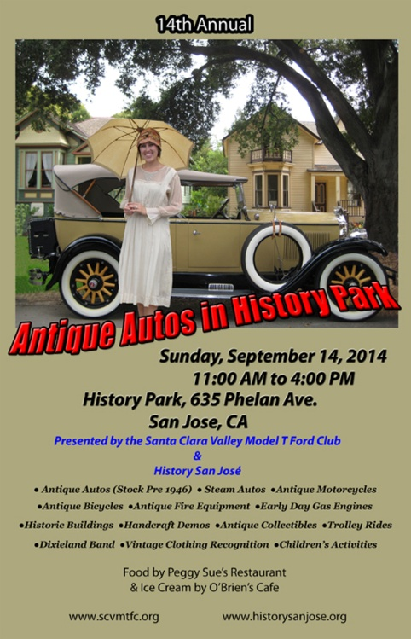Greetings Antique Auto Enthusiast. Save the date for the largest annual antique auto show in the West. The show welcomes all pre-1946 stock vehicles. This year we are featuring steam powered autos and steam engines. Displays of CA Antique Bottles,

CA License Plates, Pioneer's at Work & Play, Vintage Hats & Clothing, Vintage Car Clocks, Car –Toon, Chair Caning, Lace Making, Water Color Painting, Rug Hooking, Needle point & More.

Blacksmith Shop demonstrations , activities for children, and door prize drawings

##### +

Let's get a group together and car pool over to the show. Sign up at the meeting



Cars For Sale

1925 Runabout. Nice running car $6500

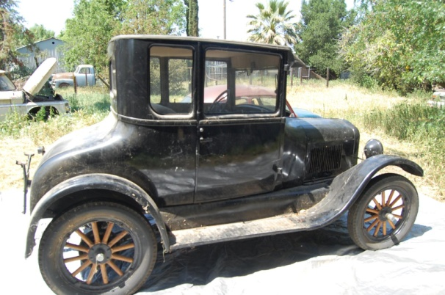Mike Carr 530-265-2079

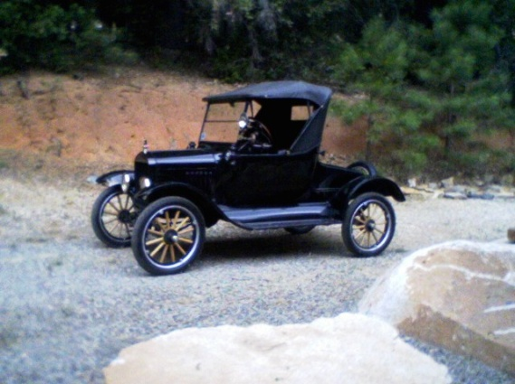

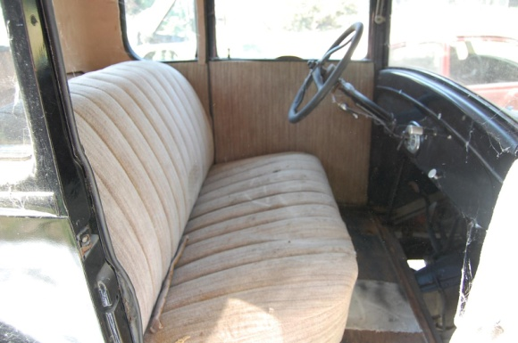

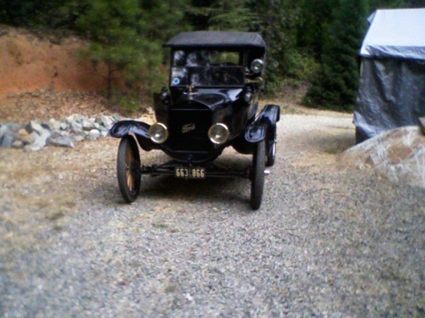

GOLD COUNTRY RUN

OCTOBER 4, 2014

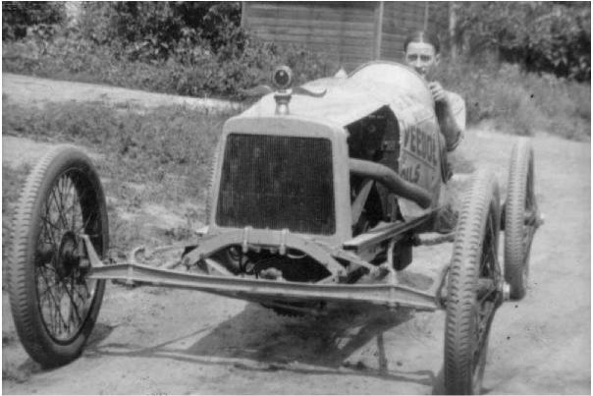

150-200 miles run starting and ending in Alta Sierra

FOR INFORMATION CALL

530 272 3994



1926 Coupe. Running Car. $9500.

Steve Fargo, 209-872-5847

*T Diggins', page 3*



**Birthdays and Anniversaries**

|  |  |  |  |  |  |  |  |  |  |  |  |  |  |  |  |  |  |  |  |  |  |  |  |  |  |  |  |  |  |  |  |  |  |  |  |  |  |  |  |  |  |  |  |  |  |  |  |  |  |  |
| --- | --- | --- | --- | --- | --- | --- | --- | --- | --- | --- | --- | --- | --- | --- | --- | --- | --- | --- | --- | --- | --- | --- | --- | --- | --- | --- | --- | --- | --- | --- | --- | --- | --- | --- | --- | --- | --- | --- | --- | --- | --- | --- | --- | --- | --- | --- | --- | --- | --- | --- |
| **September Anniversaries**   |  |  | | --- | --- | | Mike & Pat Bashore | 5 | | Russ & Nita Purvis | 7 | | Jack & Cleona Duncan | 11 | | Steven & Liz Mishler | 18 | | Bruce & Carol Fitzsimmons | 21 | | Dustin & Mary Ramsey | 27 | | Ken & Olivia Marriott | 28 | | **September Birthdays**   |  |  |  |  |  | | --- | --- | --- | --- | --- | | Richard Instness | 2 |  | Jeff Instness | 19 | | Eula Marriott | 9 |  | Mark O'Connor | 20 | | Maya Marroitt | 11 |  | Dave Barnes | 26 | | Elizabeth Porco | 15 |  | Doug Avery | 26 | | Vern Marriott | 16 |  | Helen Johnson | 28 | | Paula Mikles | 16 |  | Doris Bailey | 29 | | Al Stoll | 17 |  |  |  | |

General Meeting Minutes

Mother Lode Model T Club

General Meeting Minutes,

August 14, 2014

The August 2014, general membership meeting was called to order at 7:00 pm by President Gary Krezman. The meeting was held at the Sizzler Restaurant, Auburn, Ca.

**Greeter Report** - Junette introduced Doug Avery. Doug has purchased a TT project truck from Steve Elliott. Also in attendance was Topher Matson, his second meeting. Junette also noted Ben Pomeroy, who we have not seen in a while was in attendance.

**Secretary Report** – John reported the minutes of the last general meeting (July 2014) were printed in August *T Diggins'*. There were not any corrections or additions. Minutes will stand as printed. Correspondence from other clubs and other miscellaneous was passed around.

**Treasurer Report** – No report tonight. Kitty was home recovering from flu like symptoms.

Sunshine Report - Susie sent cards to the Duncans, Naomi Edmonds, Mary Ramsey and Joyce Weitzel.

Fran Smith, long time member has passed away. Service will be Aug 23, 11am at Herberger Family Funeral Chapel in Elk Grove.

**Activities**

**VP Susie reported the upcoming events** -

August 16 is the breakfast tour to Lincoln. September 20 is the Marriott's tour to a private mining collection.

LOL's will be at Original Pete's, Wednesday August 20.

**Old Business**

**Reports**

**July Tour**- John Saylor reported on the July poker run tour. We had a good turn out and a good time.

*(Continued next page)* *T Diggins', page 4*

*(Minutes Cont"d)*

**Trailer repair** - John, Gary and Kenny will check out the trailer and make a list of things that need to

be done and material needed and report back at the next meeting. Tentatively we have set Sept. 13

as a work day.

**Marriott Pickers Show** - Vern reported that the show will air on the History channel Wednesday August 20

**Antique Autos in History Park** - Several are talking about going. We will finalize car pooling, etc next

meeting.

**Trouble trophy -** Allen had car trouble on the way home from the poker run and had to be towed home.

Since this was after the completion of the tour, it was decided that he would not be awarded to trouble

So, Lewie will to keep it a little longer.

But **Allen did win** a trophy. He entered the CAM Cruise in Sacramento and was awarded a nice best

of class trophy.

**Cups**- Steve still has cups. Call him or see him at the meeting to reserve yours.

**Shirts** - John still has a few Tees and Polos.

**New caps** - Everyone who has seen the new caps like them. Contact Jerry Anders at 916-390-1392 to get

yours.

**New Business**

**Sweat Shirts** - Discussion on ordering sweat shirts with the club logos. A sign up was passed around to get

an idea of what is wanted.

**This Month's Tour** - Russ gave the details of this month's tour to Lincoln. We will leave Raley's at 9 am touring back roads to Lincoln where we will have breakfast at Kim's Country Kitchen. After breakfast we will have a tour of the Lincoln Archives. Sign up was passed around.

**Board Meeting** - Gary announced the next board meeting will be Monday, September 8, 7pm at the Loomis Round Table.

**Gold Country Run** - Les announced the date for this year's Run. It will be Saturday, Oct 4. Start and finish will be in Alta Sierra. The 100-150 mile run is open to all speedsters and any other T's that may want to participate. For more information call Les at 530-272-3394.

**50-50** -- Levi did the raffle, Courtney and Mia drew the winning tickets. Winners were Allen Koch and Junette Avey Brown.

Since there was no additional business the meeting was adjourned at 7:52 pm.

John Saylor, Secretary



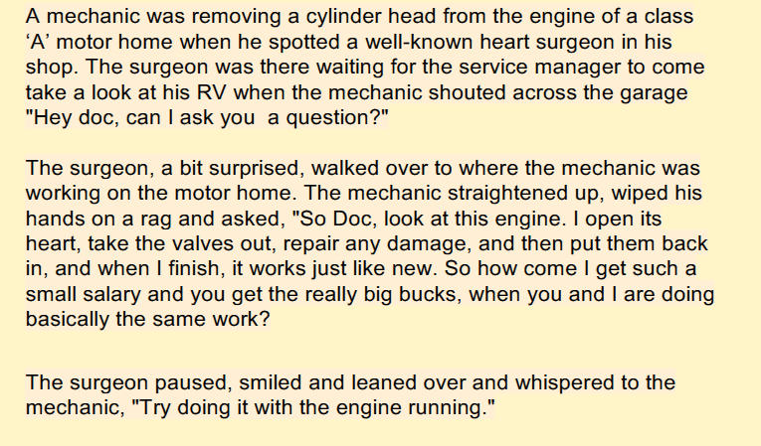***Let's go Racing***

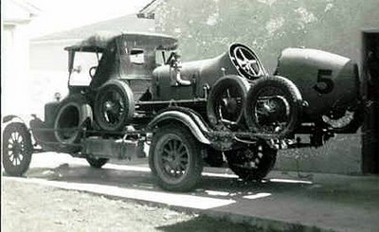

*Corona Speedway, 1913*

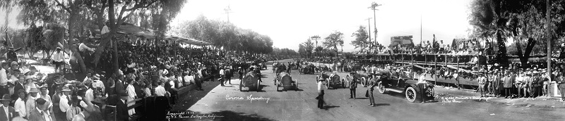

*T Diggins page 5*

***Some Laurel & Hardy Model T Funnies***

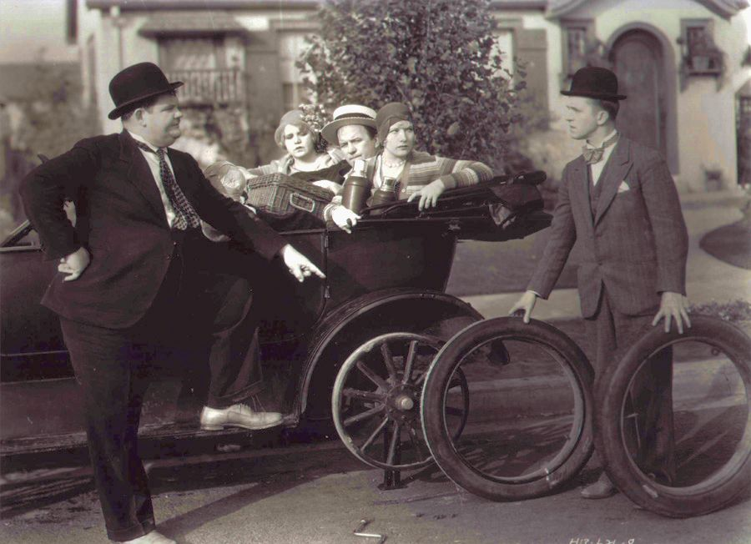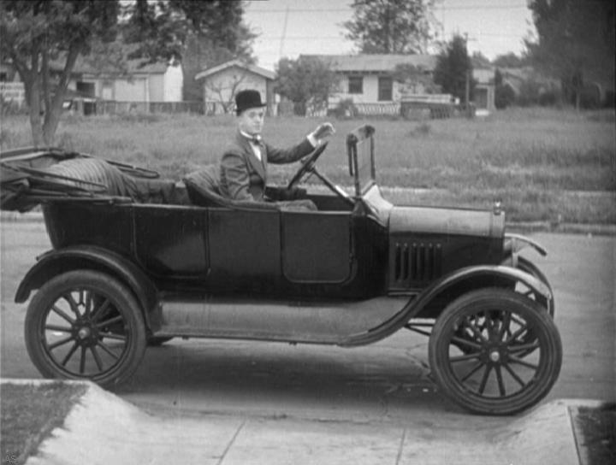

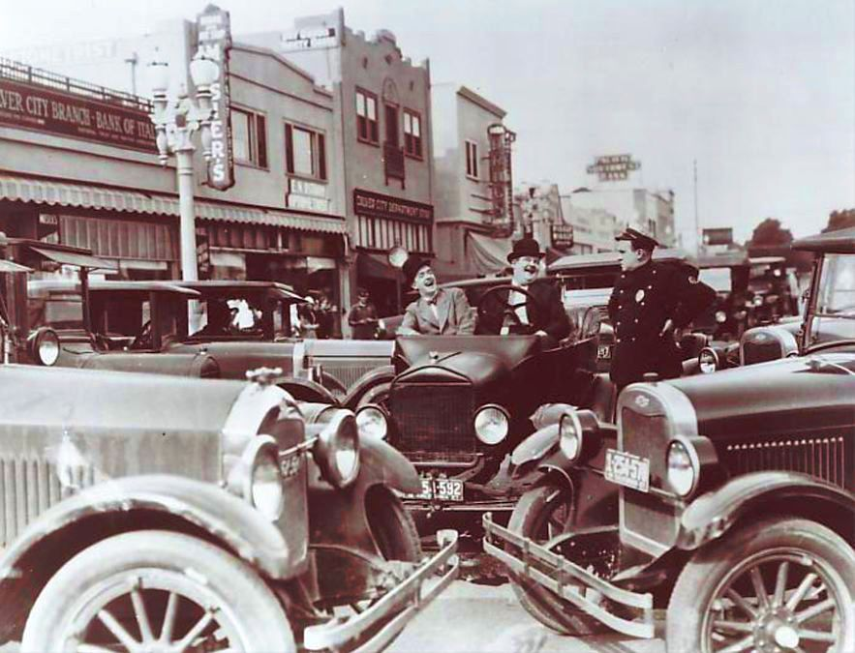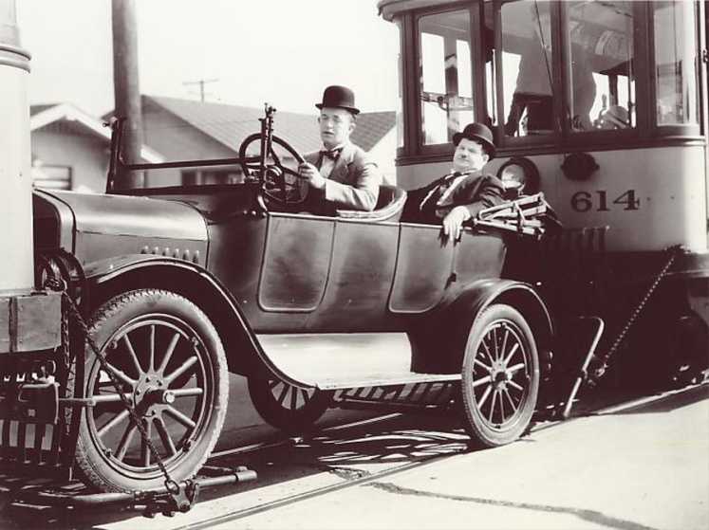

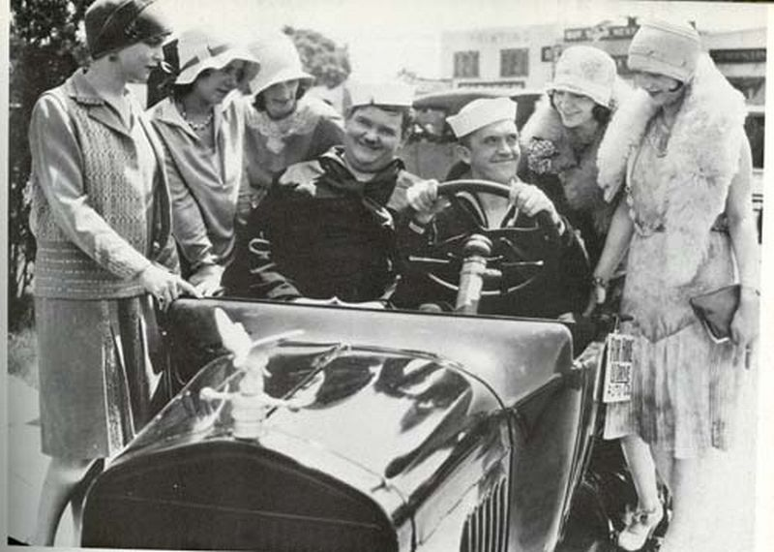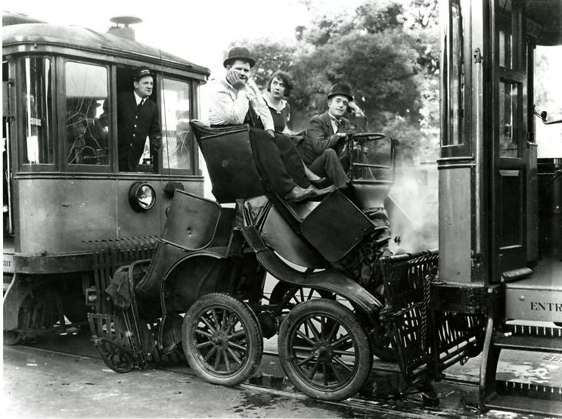

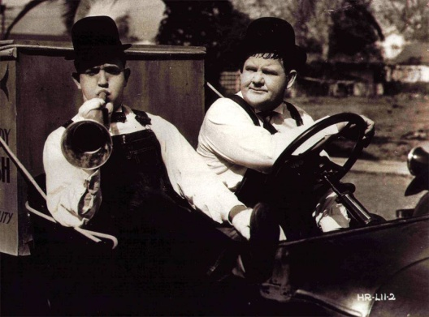

*T Diggins page 6*

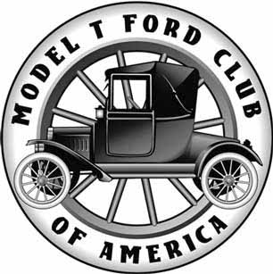

**Monthly Newsletter of the**

**Mother Lode Model T Club**

**http://www.motherlodemodelt.com**



|  |  |
| --- | --- |
| **2014 Officers**  **President ------------- Gary Krezman 530-823-7957**  **Vice President ------Susie Krezman 530-823-7957**  **Treasurer --------------Kitty Goodell 916-334-5904**  **Secretary--------------John Saylor 916-723-1613**  **Board Members**  **Gordon Goodell--------916-334-5904 - 2014-2015**  **Lewis Burcher --------- 530-885-6912 - 2014-2015**  **Junette Avey Brown --916-436-4176 - 2014-2015**  **Stephen Short --------- 916-791-7087 - 2014-2015**  **Sunshine ---- Susie Krezman**  **Website & Newsletter - John Saylor**  **\*\*\*\*\***  **Address all correspondence to:**  **Mother Lode Model T Club**  **P.O. Box 4901  Auburn, CA 95604** | **The *Mother Lode Model T Club* was organized during 1967 and became a member of the *Model T Ford Club of America* in 1969. The club is a non-profit organization dedicated to the personal enjoyment of its members through the preservation and restoration of the Model T Ford and especially through activities involving the use of Model T Fords.**  **Meetings at held on the second Thursday of each month with the exception of December, at the Sizzler, 13570 Lincoln Way, Auburn, Ca. 5:30 pm for dinner, 7 pm meeting.**  **Membership is open to anyone with an interest in Model T Fords. Ownership of a Model T is not necessary.**  **Dues - Annual Dues are $20 per family.** |

|  |  |
| --- | --- |
| **T-Diggins'**  **Published monthly to keep members informed of club activities and to promote participation in club events.**  **Publication copy should be sent to the editor by the 20th of the month to be included in the next issue. Send all copy to: 7304 Goldwood Way, Citrus Heights, Ca 95610 or email to j99saylor@gmail.com** | **Members are encouraged to join the Model T Ford Club of America. MTFCA members receive the bi-monthly publication *The Vintage Ford,* voting privileges in national club andcan participate in the many national club tours and events. Annual dues for the MTFCA is $40.00 payable to:**  **The Model T Ford Club of America**  **P.O. Box 126**  **Centerville, In 47330-0126**  **Telephone: (765) 855-5248**  **www.mtcfa.com email: admin@mtfca.com** |

|  |  |
| --- | --- |
| **Club Website**  The Mother Lode Model T Club maintains a website at **http://www.motherlodemodelt.com**. The website keeps members informed of club activities, photos of club events and members cars. The website also provides a membership information and application. The website also introduces those new to the hobby to the club. | **group ts bw.jpg** |
|  | ***T Diggins', page 7*** |